Contents
INTRODUCTION 2
INSTALLING THE MYSQL COMMUNITY SERVER 2
CONFIGURE MySQL SERVER using MySQL Configurator 5
STARTING / STOPPING MYSQL SERVER 10
INSTALLING THE MYSQL WORKBENCH 11

INTRODUCTION

There are two software that needs to be installed:
- MySQL Community Server:
The MySQL Community Server is an open-source database management system used for storing and managing data.
Visit the official MySQL website https://dev.mysql.com/downloads/mysql/ and download the installer for MySQL Community Server 8.4.5 LTS that matches your operating system.
- MySQL Workbench.
This is the application tool that you will use to manage your databases as well as write and test your SQL scripts.
Visit the official MySQL website to download the software. https://dev.mysql.com/downloads/workbench/

INSTALLING THE MYSQL COMMUNITY SERVER
- First download MySQL Community Server installer file from https://dev.mysql.com/downloads/mysql/
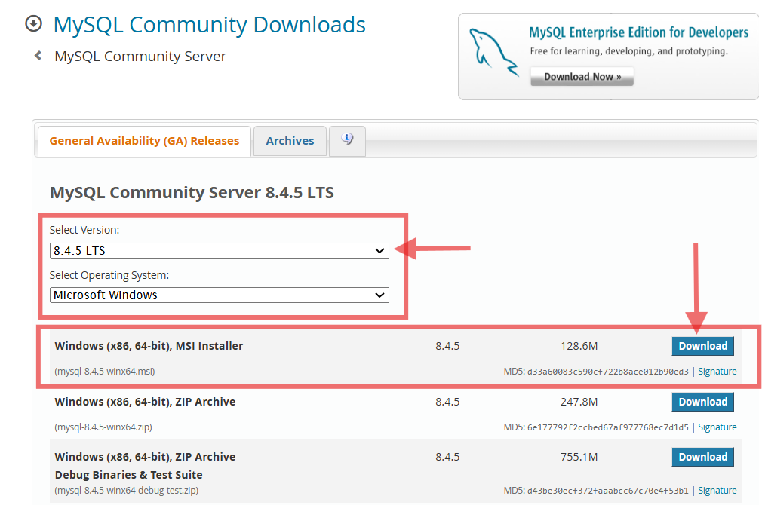

- There is no need to login or sign up for Oracle Web account. Select ‘No thanks, just start my download’.
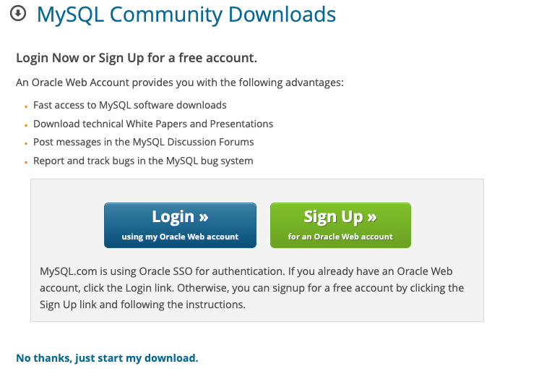

- In the Download folder of your laptop, you will find the MySQL installation package. Double click the icon to activate it.
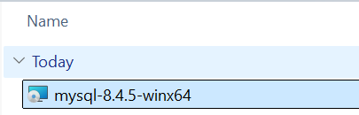

- Click ‘Next’ to execute setup
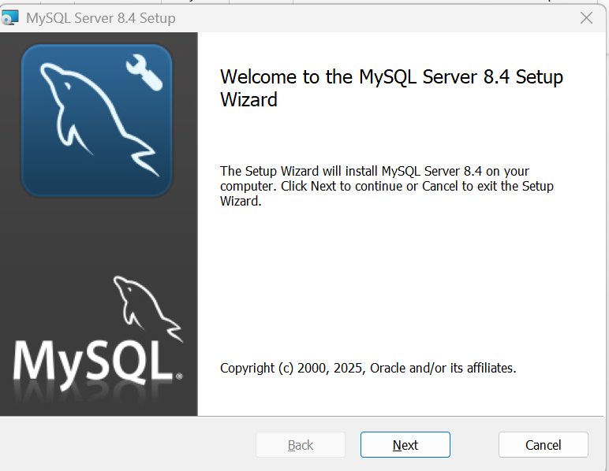

- After you have double clicked on the installation file, you will be asked to accept the terms of the licence agreement. ‘Checked’ the checkbox. Click ‘Next’
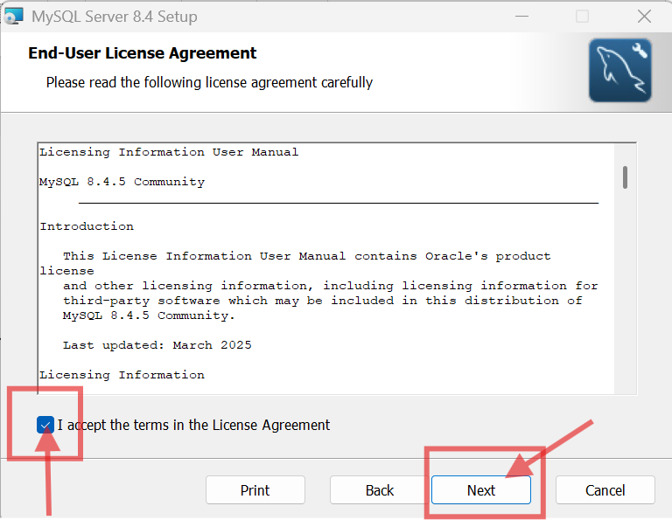

- You will be prompted to select the set-up type. Select ‘Typical’
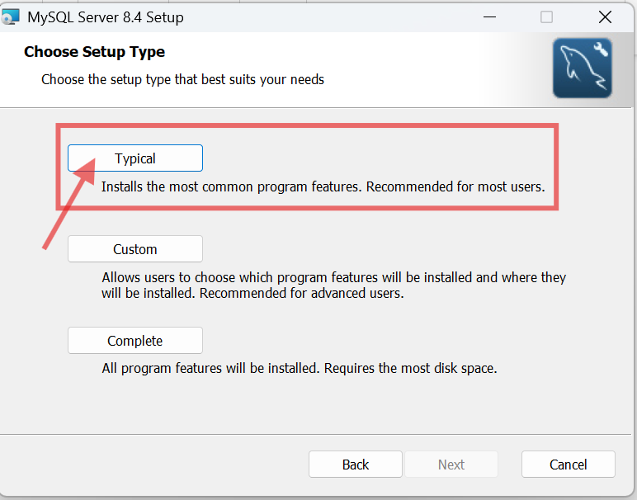
- Click the ‘Install’ button.

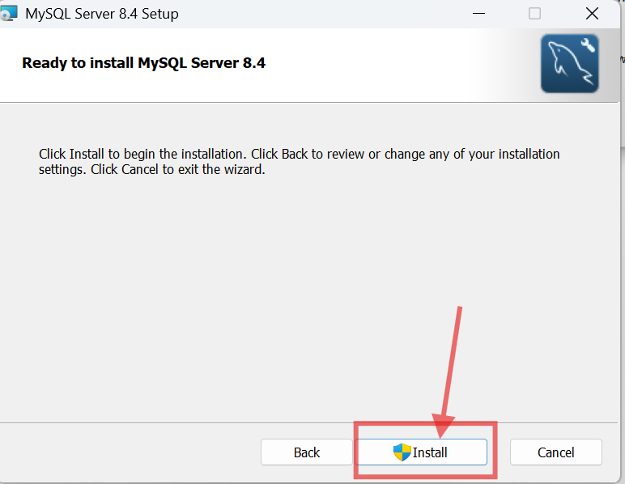

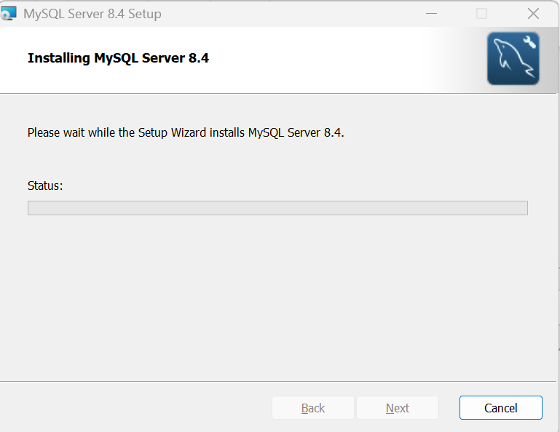

- Select the ‘Finish’ button. Ensure ‘Run MySQL Configurator’ is selected.

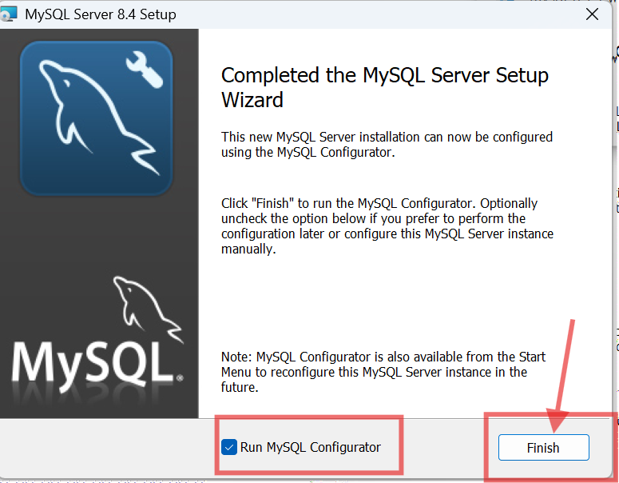

CONFIGURE MySQL SERVER using MySQL Configurator

- Click ‘Next’
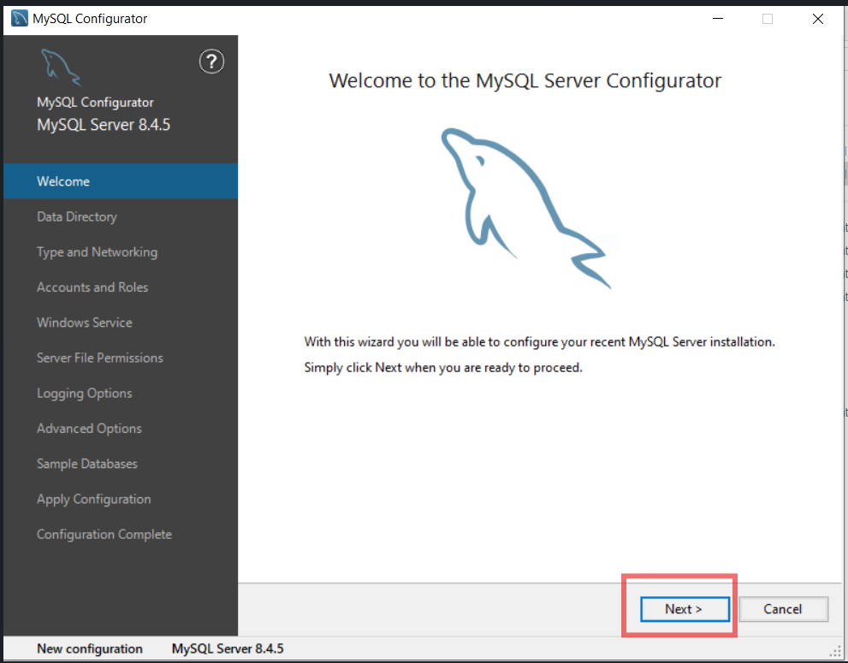

- Click ‘Next’ to use default Data Directory
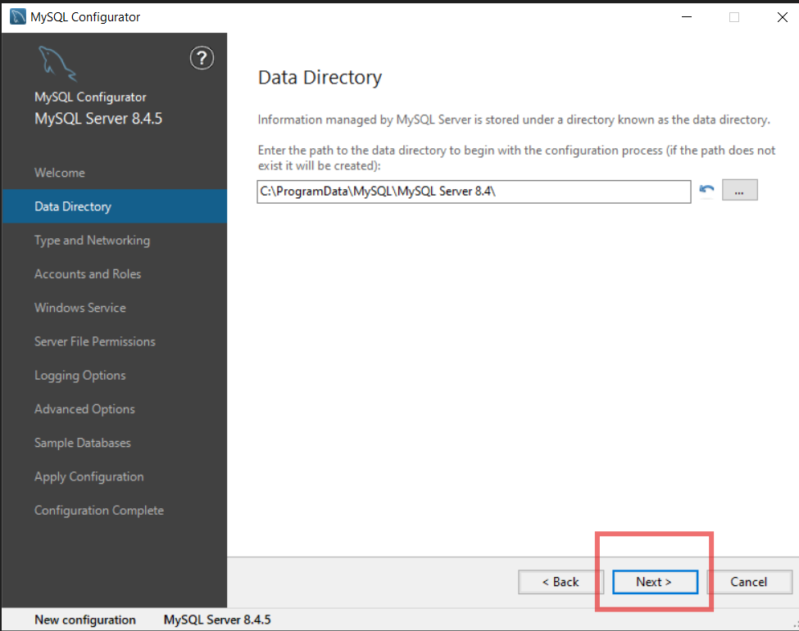

- Click ‘Next’ to use Default setting
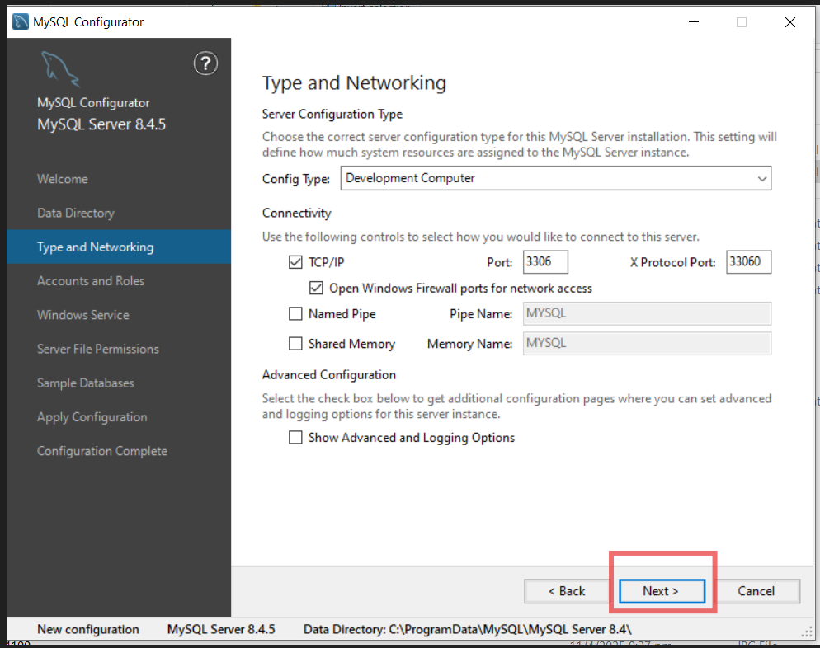
- When prompted to enter root password, we recommend you enter RP738964$ so that if you forget you can refer to this document for the password. If you enter your own password, you MUST remember it otherwise you will need to uninstall and reinstall MySQL Server.
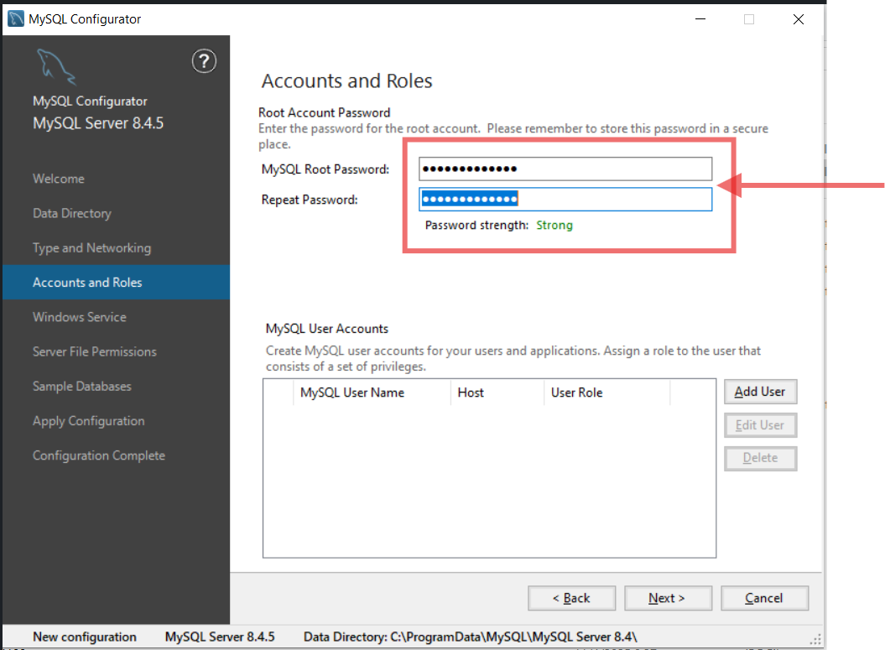
Enter RP738964$
The following screens in Table A are for those with existing MySQL Server installed.

Table A: Upgrading MySQL server.
Choose ‘Perform an in-place upgrade of the existing.’  The previous run password is ‘Republic_C207’.  Click Connect.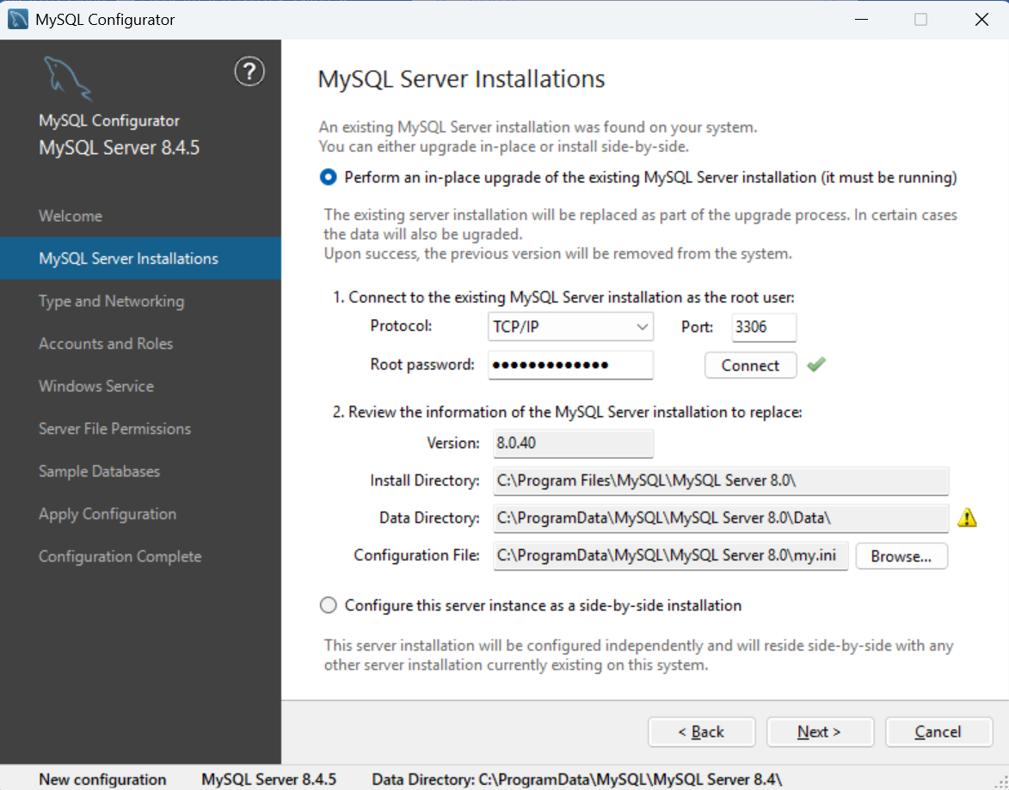 | Click ‘Next’ to Backup Data  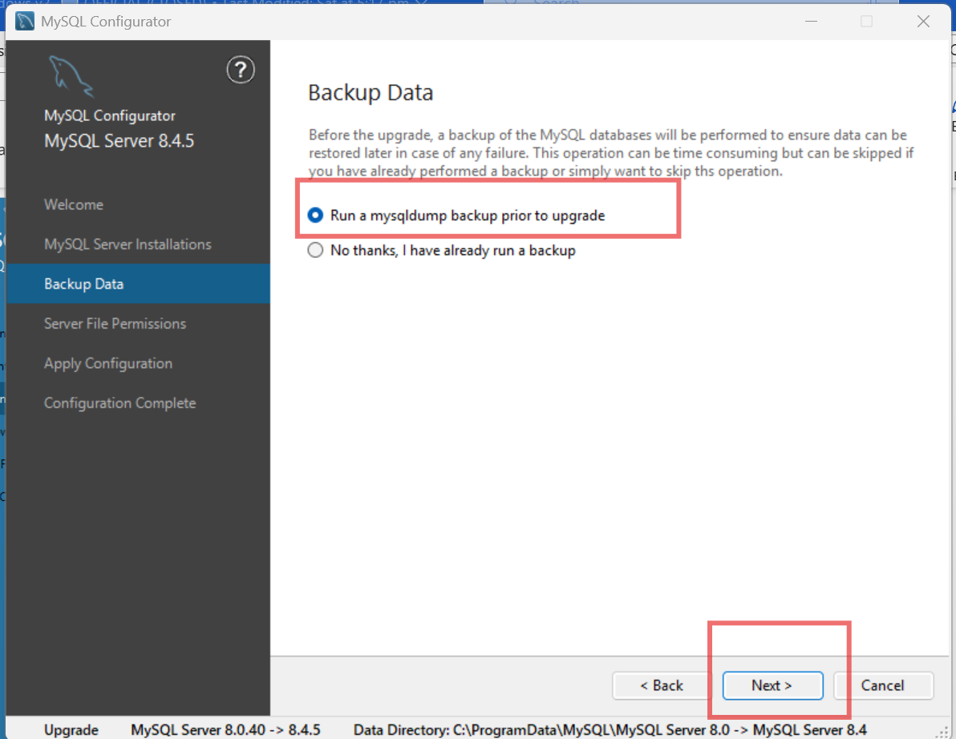

13. Click ‘Next’
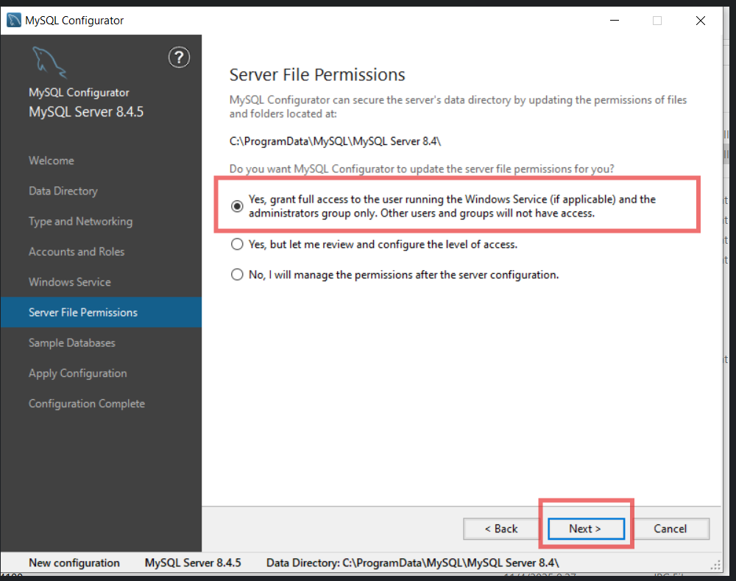

14. For new setup, you will be prompted the following. Click ‘Next’. You don’t need sample database.
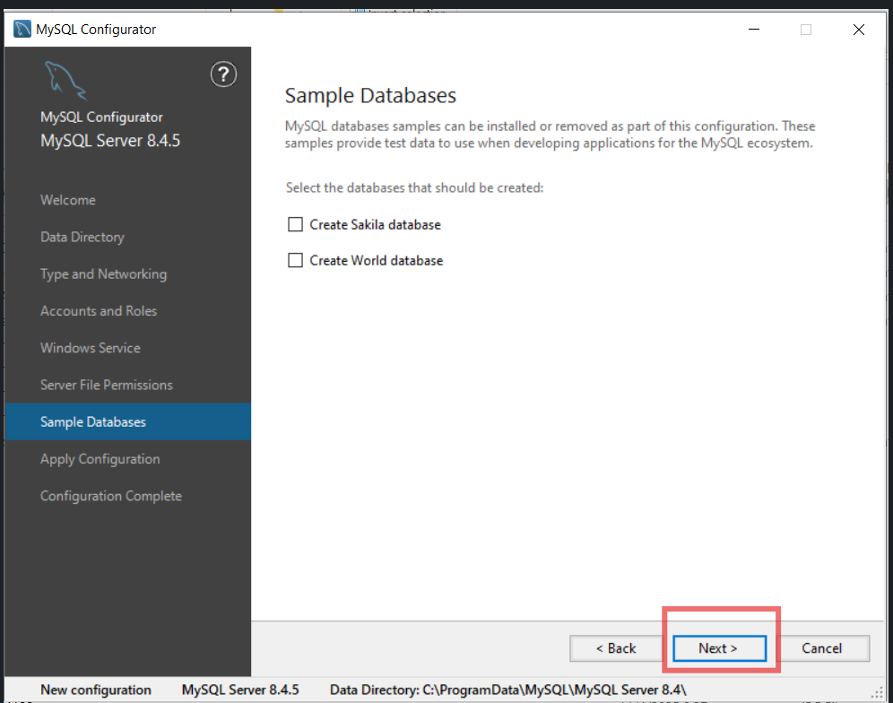

15. Click ‘Execute’
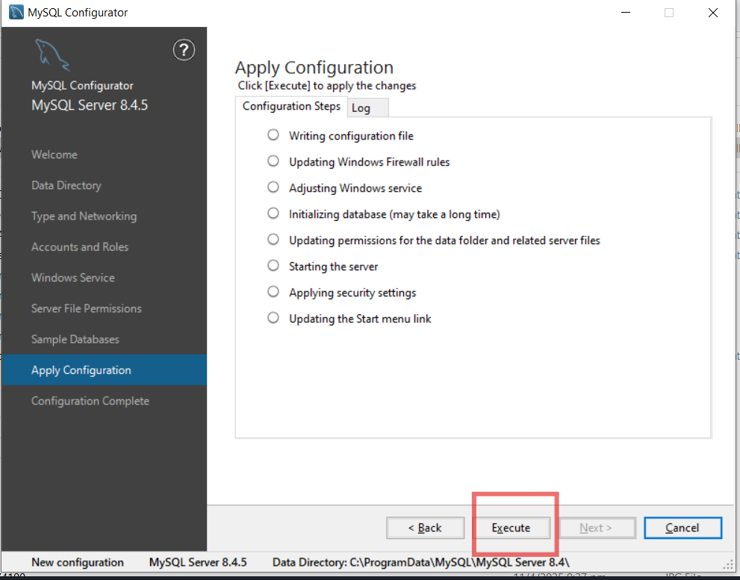

15. Click ‘Next’

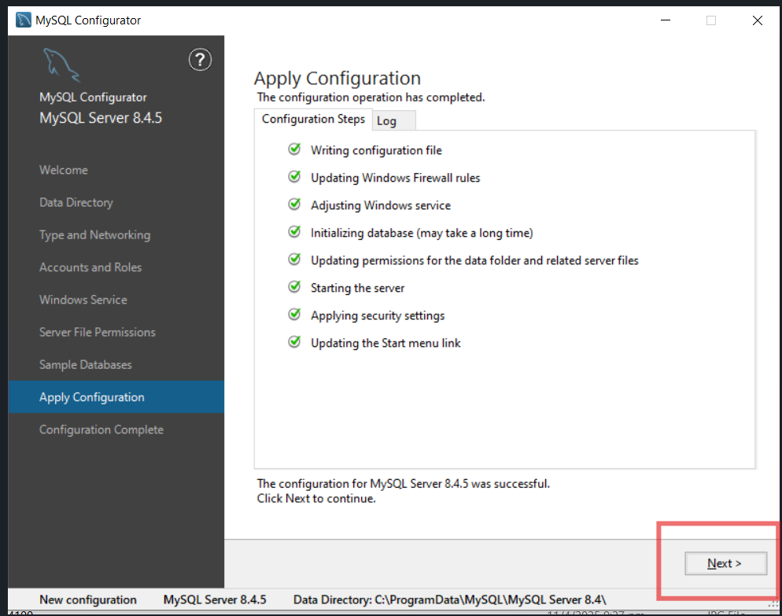

16. Click 'Finish’
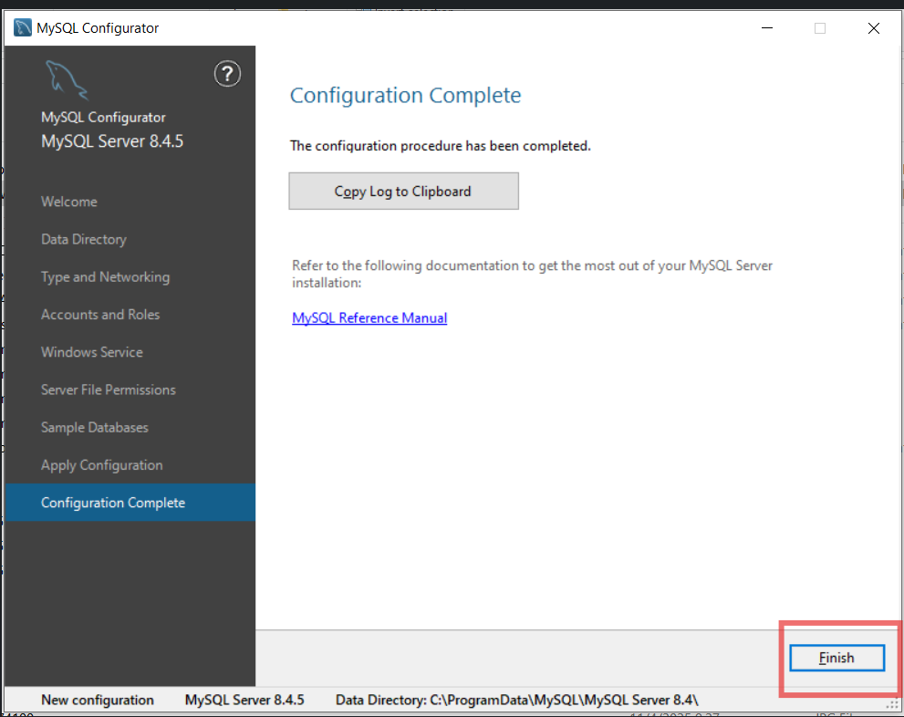

STARTING / STOPPING MYSQL SERVER
- Run ‘Task Manager’
- Select ‘Services’ tab’. Then type ‘MySQL’ in the search bar.
- Check that ‘MySQL84’ service is running.
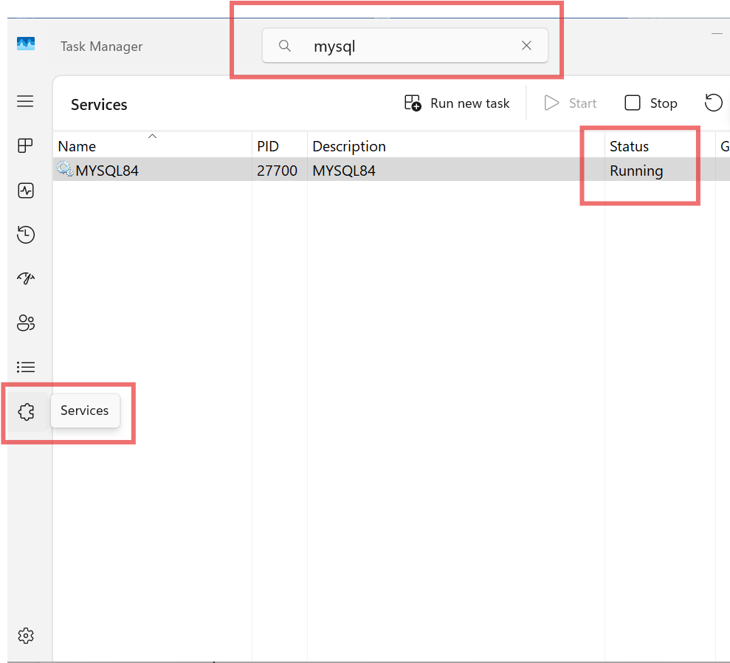

- If service is stopped. Right-Click to choose ‘Start’ option
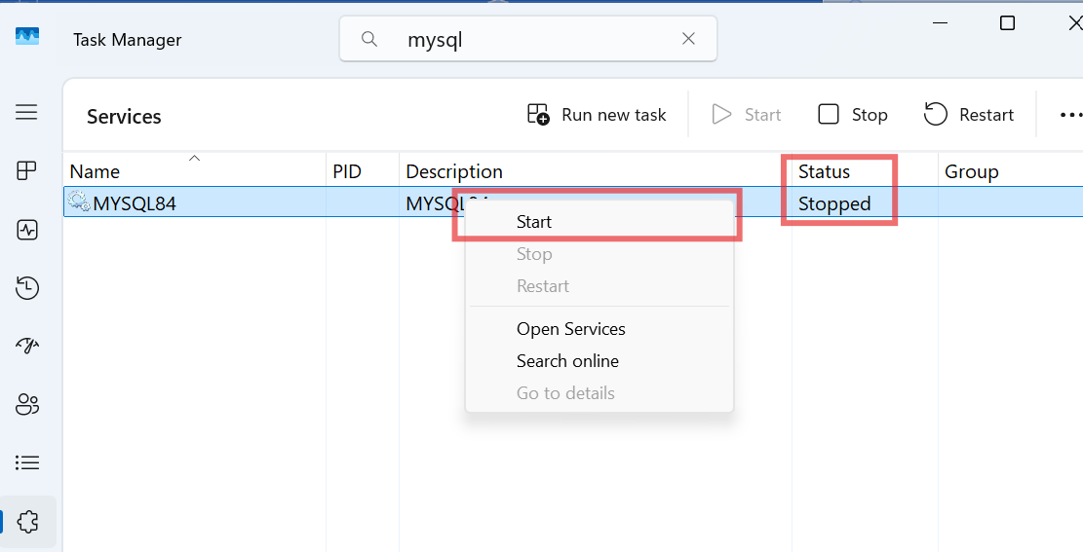

INSTALLING THE MYSQL WORKBENCH
- Go to https://dev.mysql.com/downloads/workbench/ MySQL :: Download MySQL Workbench
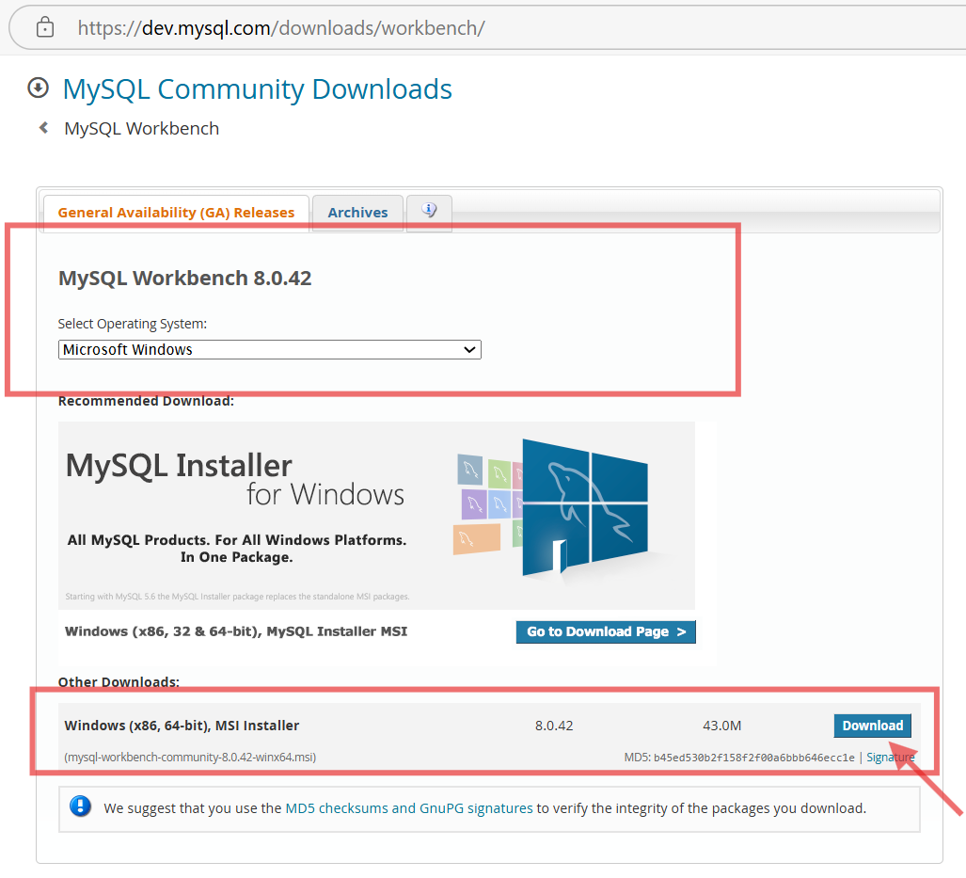

- Select ‘No thanks, just start my download’ when prompted to sign up or login.
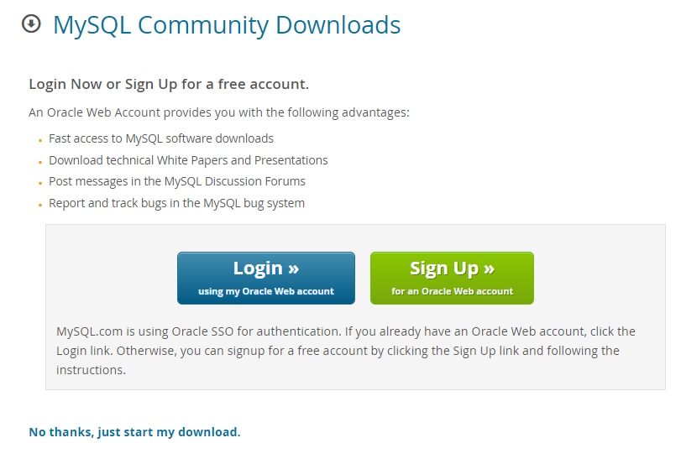

- In your Download folder of your laptop, you will find the installation package. Double click the icon to activate it.
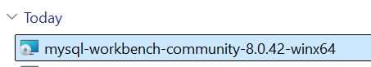

- Click the ‘Next’ button.
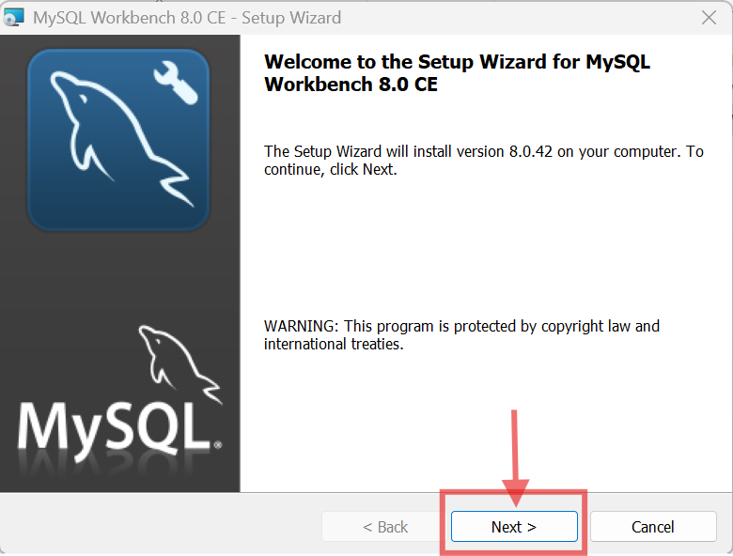

- Click the ‘Next’ button.
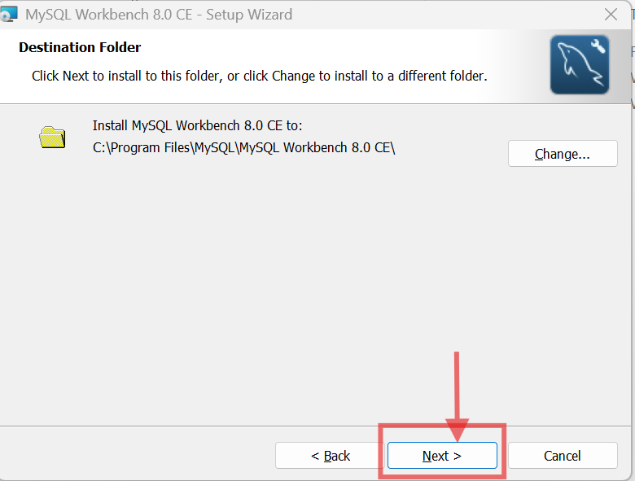

- Select ‘Complete’ option then click ‘Next’
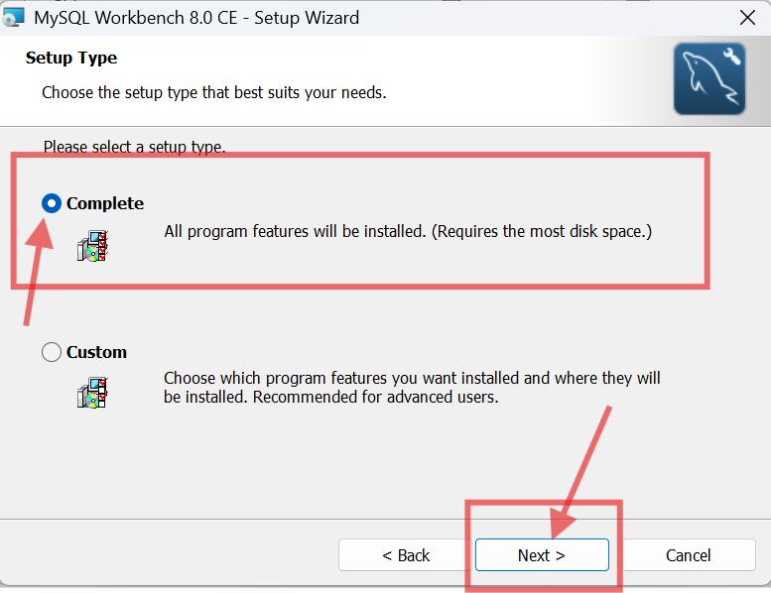

- Select the ‘Install’ button and allow the app to make changes on your laptop when prompted.
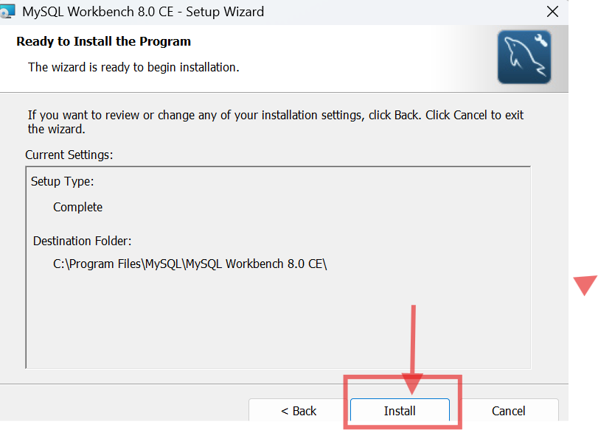

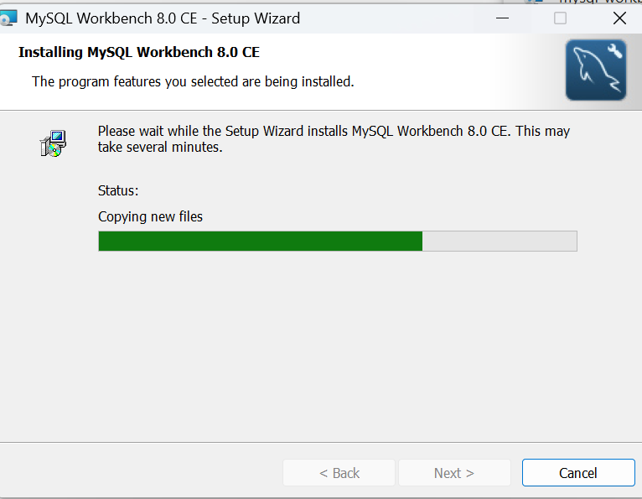

- Select the ‘Finish’ button when prompted.
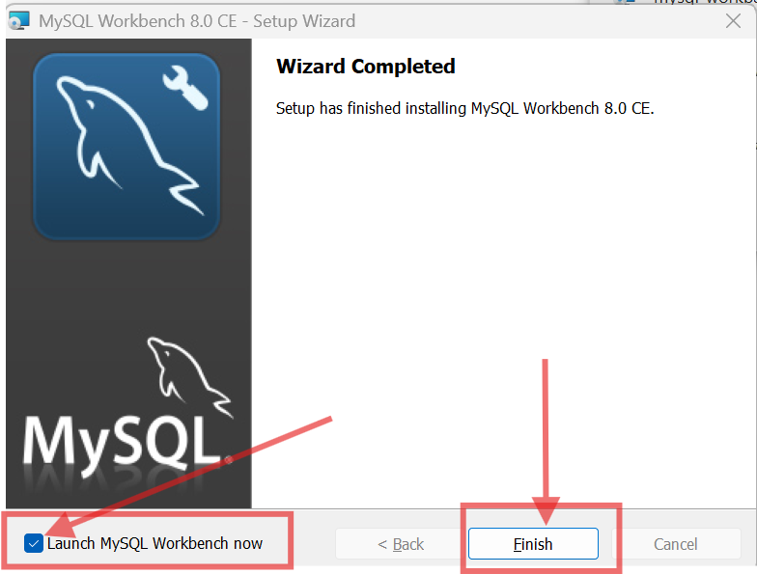

- MySQL Workbench will start. For now, you just need to close the app. You will learn how to use the app during Lesson 1.
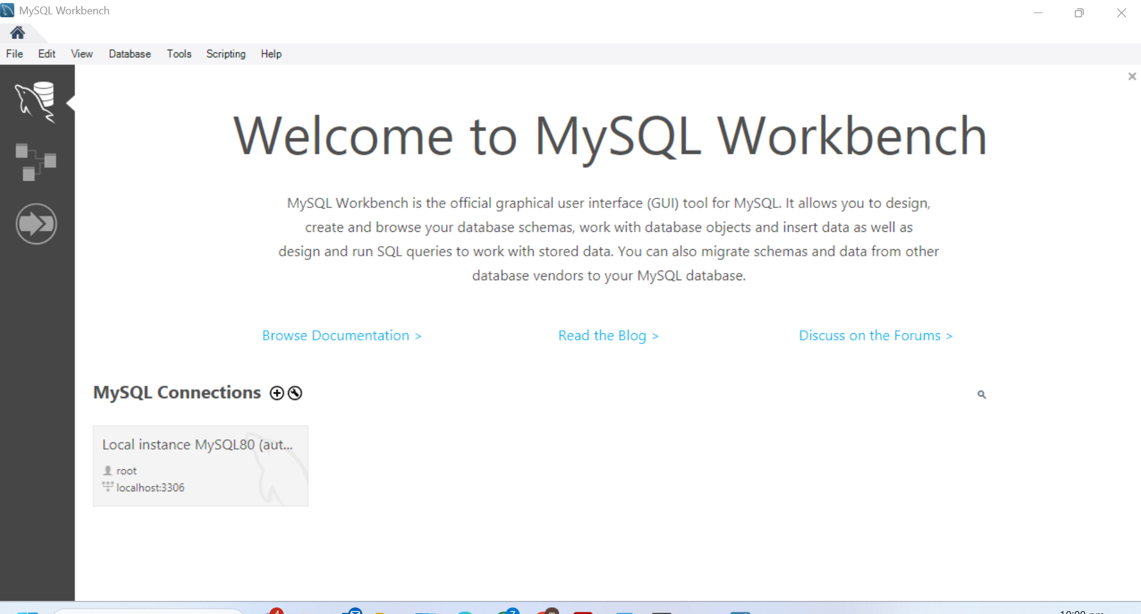

- You have successfully installed MySQL Server and MySQL Workbench. MySQL Server is the database management system and MySQL Workbench is the SQL editor for you to test your SQL statements.

